System and Software Architecture Description (SSAD)

LADOT Scanning

Team 08

Name | Primary Role | Secondary Role
Anirudh Govil | Project Manager | Life Cycle Planner
Jeffrey Colvin | Prototyper | Systems and Software Architect
Aditya Kumar | Feasibility Analyst | Project Manager
Nisheeth Joshi | Systems and Software Architect | Life Cycle Planner
Niraj Brahmkhatri | Operational Concept Engineer | Requirements Engineer
Corey Painter | IIV&V | Shaper

Version History
Date | Author | Version | Changes made | Rationale
10/09/11 | JC | 1.0 | - Original copy using with Instructional ICM-Sw v1.0 template | - Initial Draft
10/10/11 | Nisheeth Joshi | 1.1 | - Updated section 2.0 template | - Initial Draft
10/16/11 | NJ | 1.2 | - Updated incorrect text associated with diagrams | - TA Grading
10/10/11 | JC | 2.0 | - Updated diagrams | - Diagrams misrepresented system and were not detailed enough
10/23/11 | JC | 3.0 | - Modified diagrams | - Diagrams needed corrections due to rescoping/ARB session comments
10/24/11 | JC | 3.1 | - Added future considerations  - Fixed some typos | - Needed to meet requirements
10/27/11 | NJ | 3.2 | - Fixed some common error | - Changes as per the bugs marked by den student
11/21/11 | JC | 3.3 | - Merged Models with <<evolutionary>> tags  - Updated Use Case descriptions with more in depth information  - Modified use case descriptions | - Feedback from DCP  - Requirement changes
12/05/11 | JC | 3.4 | - Added xml tag specification | - Feedback from ARB

Table of Contents
System and Software Architecture Description (SSAD) i
Version History ii
Table of Contents iii
Table of Tables v
Table of Figures vi
1. Introduction 1
1.1 Purpose of the SSAD 1
1.2 Status of the SSAD 1
2. System Analysis 2
2.1 System Analysis Overview 2
2.1.1 System Context 2
2.1.2 Artifacts & Information 3
2.1.2.1 Artifacts XML Summary 4
2.1.2.1.1 IssueCodes.xml File Format 4
2.1.2.1.2 IssueRelations.xml File Format 4
2.1.2.1.3 Locations.xml File Format 4
2.1.2.1.4 UserTable.xml File Format 5
2.1.2.1.5 VariationCodes.xml File Format 5
2.1.2.1.6 WorkOrderCodes.xml File Format 5
2.1.2.1.7 <Jobs>.xml File Format 5
2.1.2.1.8 <LoggedIssue>.xml File Format 6
2.1.2.1.9 <LoggedIssueComments>.xml File Format 6
2.1.3 Behavior 7
2.1.3.1 Use-Case Model 7
2.1.3.1.1 Log job call 7
2.1.3.1.2 Perform Job 8
2.1.3.1.3 Select Job 8
2.1.3.1.4 Truck Login 9
2.1.3.1.5 Truck Logout 9
2.1.3.1.6 Register Job Issues 9
2.1.3.1.7 Evolutionary Use Case Information 10
2.1.3.1.7.1 View location job history 10
2.1.3.1.7.2 View Own Employee Job History 10
2.1.3.1.7.3 Web Login 11
2.1.3.1.7.4 Web Logout 11
2.1.3.1.7.5 View Maintenance Report 11
2.1.3.1.7.6 Edit Maintenance Report 12
2.1.3.1.7.7 View Truck Map Near Task 12
2.1.3.1.7.8 View Task Map Near Truck 12
2.1.3.1.7.9 Mark Task as Assigned to Truck 13

Table of Tables
Table 1 - System Context Diagram Details 2
Table 2 - Artifacts and Information Diagram Details 3

Table of Figures
Figure 1 - System Context Diagram 2
Figure 2 - Artifacts and Information Diagram 3
Figure 3 - Truck System Use-Case Model 7

Introduction

Purpose of the SSAD

The SSAD will outline the overall object-oriented analysis and design (referred to as OOA&D) of the system being developed. The system, once developed, should be faithful to the architecture defined in the SSAD and the builders (programmers) should use this document as a reference to the system architecture. Additionally, the SSAD may be used by the maintainer and clients to understand the structure of the system after the system has been delivered.

Status of the SSAD
This version of the SSAD specified the XML tags that are associated with the prototype data files as well as value specifications.

System Analysis

System Analysis Overview
The purpose of the new LADOT Scanning System is to eliminate the current document scanning process and to create a new electronic system to help maintain both time-keeping and maintenance reports for LADOT field workers. The LADOT Electronic Field System will be stored on LADOT trucks and will log job status (including time stamps) as well as notes about the job such as what the problem was and what equipment was needed to fix it. The software must only keep track of maintenance reports.

Additionally, an evolutionary web system will support helping with task assignment by showing maps with tasks and trucks. There will also be pages to review maintenance reports by specific queries.

System Context

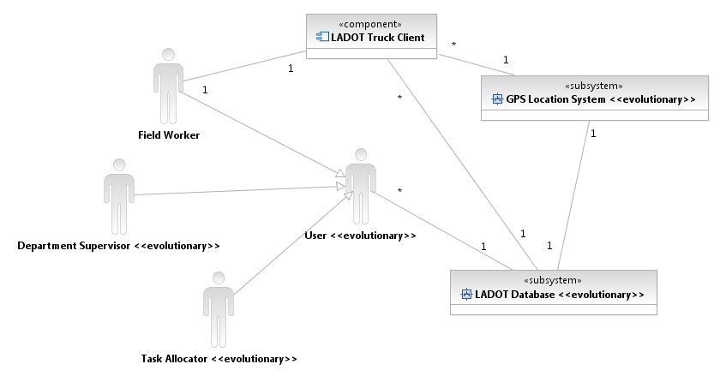
Figure 1 - System Context Diagram
Table 1 - System Context Diagram Details
Actor | Description | Responsibilities
User | A super-type | A generalized actor for log-in on the computer system
Task Allocator | Person who will be choosing which tasks to allocate to certain trucks | Allocating tasks to trucks
Department Supervisor | A supervisor needing to create maintenance report logs | Query the database for logs
Field Worker | Employees who go to the field and do the work | Log job reports  View old logs

Artifacts & Information
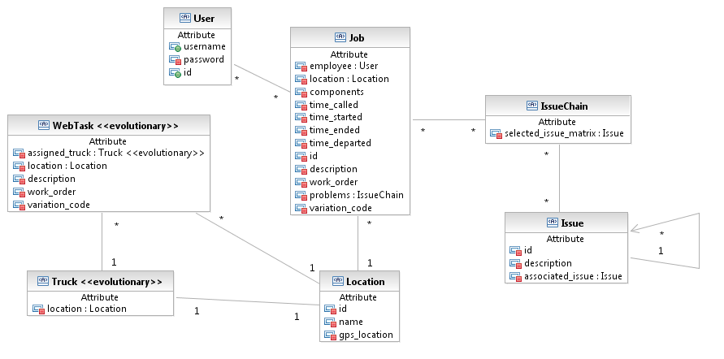
Figure 2 - Artifacts and Information Diagram

Table 2 - Artifacts and Information Diagram Details
Artifact | Purpose
Issue | This keep a note of one of the issues that were resolved during a job (ex: broken red light on east-facing lamp)
Job | A representation of a job being performed by a field worker after it has been assigned
Truck | A representation of a truck in the field, including it’s location
User | A user of any of the systems (either truck of computer system) depending on their permission attribute
IssueChain | This stores a complete set of issues in a list of lists, and is a representation of the depth of sub issues in relation to each other
Location | Either a job location (28th and Figuroa) or the location of a truck, depending on the owner
Web Task | A representation of a task that needs assigning (note: this is not linked to a Job as trucks are not guaranteed to have internet connectivity. Field Worker’s must manually input task data into the computer system Job artifact)

Artifacts XML Summary
This section will outline the tags used in the XML files read and generated by the application. They link to the columns a database should contain.

Fields marked as “(unique)” must be unique for the program to run correctly. When a new value is added, it should be a non-existing number otherwise old data will no longer be correct.

IssueCodes.xml File Format
Tag | Description | Contains
DocumentElement | An overall container tag | T_ISSUE_CODES
T_ISSUE_CODES | A row definition for an issue | id, description, checkbox
id | The issue codes id | Integer (unique)
description | The issue codes description | String
checkbox | Whether or not this issue is part of a list of issues that allow multiple selections | Boolean (0 or 1) for true false

IssueRelations.xml File Format
Tag | Description | Contains
DocumentElement | An overall container tag | T_ISSUE_RELATIONS
T_ISSUE_RELATIONS | A row definition for a relationship | parent_id, child_id
parent_id | The id of the issue code that acts as the parent | Integer (should be identical to an id in the Issue Codes table)
child_id | The id of the issue code that acts as the child | Integer (should be identical to an id in the Issue Codes table)

Locations.xml File Format
Tag | Description | Contains
DocumentElement | An overall container tag | T_LOCATIONS
T_LOCATIONS | A row definition for a location | location_code, hi_axis, low_axis
location_code | The location code | Integer (unique)
hi_axis | The first cross-street | String
low_axis | The second cross-street | String

UserTable.xml File Format
Tag | Description | Contains
DocumentElement | An overall container tag | T_USER
T_USER | A row definition for an user | user_id, user_password, user_name
user_id | The user’s id | Integer (unique)
user_password | The user’s password | String
user_name | The user’s display name | String

VariationCodes.xml File Format
Tag | Description | Contains
DocumentElement | An overall container tag | T_VARIATION_CODES
T_VARIATION_CODES | A row definition for a variation code | code
code | The variation code | Integer (unique)

WorkOrderCodes.xml File Format
Tag | Description | Contains
DocumentElement | An overall container tag | T_WORK_ORDERS
T_WORK_ORDERS | A row definition for a work order | code
code | The work order code | Integer (unique)

<Jobs>.xml File Format
Multiple files contain job definitions. This file should never be hand-generated, it is created by the application.
Tag | Description | Contains
DocumentElement | An overall container tag | T_JOB
T_JOB | A row definition for a job | user_id, work_order_id, time_called, time_arrived, time_completed, time_departed, variation_code, unique_id, location_code
user_id | The performer’s user id | Integer (links to user table)
work_order_id | The job’s work order id | Integer (links to work order table, -1 if unassigned)
time_called | The time call was received | DateTime
time_arrived | The time arrived at job location | DateTime (DateTime.Min if unassigned)
time_completed | The time job was completed | DateTime (DateTime.Min if unassigned)
time_departed | The time job was departed | DateTime (DateTime.Min if unassigned)
variation_code | The variation code | Integer (links to work order table, -1 if unassigned)
unique_id | A unique id for the job | GUID (unique)
location_code | The location of the job | Integer (links to location table, -1 if unassigned)

<LoggedIssue>.xml File Format
Multiple files contain logged issue definitions. This file should never be hand-generated, it is created by the application.
Tag | Description | Contains
DocumentElement | An overall container tag | T_LOGGED_ISSUE
T_LOGGED_ISSUE | A row definition for a logged issue | issue_user_id, issue_job_id, issue_depth_int, issue_id, issue_chain_id
issue_user_id | The user who logged the issue | Integer (links to user table)
issue_job_id | The job the issue is associated with | GUID (links to job table)
issue_depth_int | The depth of the issue in relation to the chain | Integer
issue_id | The issue represented | Integer (links to issue table)
issue_chain_id | The id of the chain | GUID (shared with other issues in same chain)

<LoggedIssueComments>.xml File Format
Multiple files contain logged issue comment definitions. This file should never be hand-generated, it is created by the application.
Tag | Description | Contains
DocumentElement | An overall container tag | T_LOGGED_ISSUE_  COMMENTS
T_LOGGED_ISSUE_  COMMENTS | A row definition for a issue chain comment | job_code, comment, issue_chain_id
job_code | The job the comment is associated with | GUID (links with job table)
comment | The comment | String (empty string if unassigned)
issue_chain_id | The issue chain this comment is associated with | GUID (links with logged issue table)

Behavior

Use-Case Model
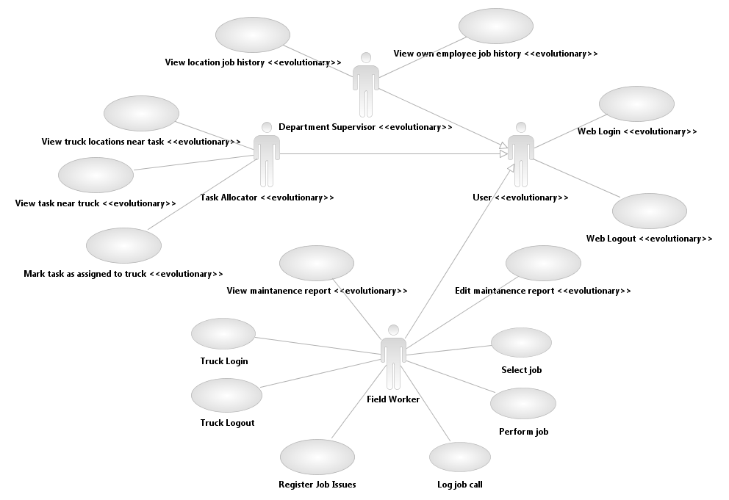
Figure 3 - Truck System Use-Case Model

Log job call
Identifier | UC-01: Log job calls
Purpose | Field worker needs to log that they were called with a job
Requirements | WC_523 Time stamp maintenance events
Pre-conditions | Must be using the truck system
Post-conditions | New call is added to the unregistered job queue

Seq# | Actor’s Action | System’s Response
1 | Select “Log Call” button
2 |  | Generate new empty “job” and adds to un-registered job list
3 |  | Mark “call received” time as current time

Perform Job
Identifier | UC-02: Perform job
Purpose | Field worker needs to be able to log that they have performed a job
Requirements | WC_536 Standardize tasks to be entered; WC_523 Time stamp maintenance events
Pre-conditions | Must be logged into the truck system; must have job registered; must not be performing another job; must have been selected from UC-03 (Select job)
Post-conditions | Job is completed (has departure time logged) with issues and is stored to completed job list

Seq# | Actor’s Action | System’s Response
1 | Select “Log Arrival” upon arrival
2 |  | Time-stamp arrival in job
3 | Select “Log Completion” upon completing
4 |  | Time-stamp completion
5 | Ensure “Register Job Issues” has been performed at least once
6 | Select “Log Departure” when departing
7 |  | Time-stamp departure and close job

Select Job
Identifier | UC-03: Select job
Purpose | Field worker needs to be able to choose which job to do
Requirements | WC_1048 and WC_536 Retrieval of codes and Standardize tasks to be entered
Pre-conditions | Must be logged in; must not be performing another job; must have registered jobs in queue
Post-conditions | Job is registered as being performed

Seq# | Actor’s Action | System’s Response
1 |  | Load list of registered job in queue
2 | Select job from queue
3 | Select “begin job” button
4 |  | Register job as started, transfer to Perform Job page

Truck Login
Identifier | UC-04: Truck Login
Purpose | Field worker needs to be able to log-in to perform jobs
Requirements | WC_521 Log in
Post-conditions | User is logged into the system

Seq# | Actor’s Action | System’s Response
1 | Enter username and password
2 | Submit data
3 |  | Validate username/password
 |  | Time-stamp beginning of user session
4 |  | Store user data in code until logout

Truck Logout
Identifier | UC-05: Truck Logout
Purpose | Need to be able to log-out to have other users sign on and to export data
Requirements | WC_521 Log out
Pre-conditions | Must be logged in to the truck system
Post-conditions | User is logged out of the system

Seq# | Actor’s Action | System’s Response
1 | Click logout button
2 |  | Time-stamp end of user session
3 |  | Save user session until exported

Register Job Issues
Identifier | UC-06: Register Job Issues
Purpose | Field worker must be able to register what issues arised at the job
Requirements | WC_536 Standardize tasks to be entered
Pre-conditions | Must be logged in; must be performing a job
Post-conditions | New issue chain is added to the current job

Seq# | Actor’s Action | System’s Response
1 | Select “Log Job Issue” from the job performance page
2 |  | Load the log issue popup
3 |  | Load the entry set of issues into the popup
4 | Select an issue(s) from either the dropdown or list
5 |  | Load set of child issues (if exists)
6 | Repeat 4&5 until entire chain has been created
7 | Select “Save Issue”
8 |  | Create issue chain and save to current job
9 |  | Return to perform job page

Evolutionary Use Case Information
The evolutionary use cases are not tied to specific requirements and as such contain no “requirements” information. These evolutionary clauses are aspects that were taken into account during the development of the project, but must be re-assessed when continued with future development.

View location job history
Identifier | UC-07: View location job history
Purpose | Review the jobs that have been performed at a specific location
Pre-Conditions | Must be logged into the web system with Department Superisor permissions
Post-Conditions | User is allowed to view the history of jobs performed at the location

Seq# | Actor’s Action | System’s Response
1 | Enter location id
2 | Click “view”
3 |  | Validate id existence
4 |  | Query database for jobs with location id
5 |  | Return table of jobs performed on location chronologically

View Own Employee Job History
Identifier | UC-08: View Own Employee Job History
Purpose | Review job performance by a certain individual
Pre-Conditions | Must be logged into the system with Department Superisor permissions
Post-Conditions | User is allowed to view the history of jobs performed by the employee

Seq# | Actor’s Action | System’s Response
1 | Enter employee id
2 | Click “view”
3 |  | Validate id existence
4 |  | Validate user permission for id
5 |  | Query database for jobs completed by employee id
6 |  | Return table of jobs performed by employee chronologically

Web Login
Identifier | UC-09: Web Login
Purpose | To log in to the online system
Post-Conditions | User is logged into the online system

Seq# | Actor’s Action | System’s Response
1 | Enter username and password
2 | Submit data
3 |  | Validate username/password
4 |  | Store user data as encrypted cookie until log out

Web Logout
Identifier | UC-10: Web Logout
Purpose | To log out of the online system
Pre-conditions | Must be logged into the online system
Pre-conditions | User is logged out of the online system

Seq# | Actor’s Action | System’s Response
1 | Click logout button
2 |  | Remove user cookie

View Maintenance Report
Identifier | UC-11: View maintenance report
Purpose | Field worker can review their maintenance reports
Pre-conditions | Must be logged in to the online system with field worker permissions
Post-conditions | User can review a specific maintenance report

Seq# | Actor’s Action | System’s Response
1 | Select report to view from list
2 | Click “View” button
3 |  | Displays read-only job summary until “Back” or “Edit” button is selected

Edit Maintenance Report
Identifier | UC-12: Edit maintenance report
Purpose | Employees must be able to edit reports in case of mistakes
Pre-conditions | Must be logged in to the online system with field worker permissions
Post-conditions | Maintenance report is updated and stored to database

Seq# | Actor’s Action | System’s Response
1 | Select “Edit” button on view report page
2 |  | Display job page with editable fields
3 | Edit fields in need of changing
4 | Click “Submit” button
5 |  | Update changed fields in job database
6 |  | Change page to “view report” page

View Truck Map Near Task
Identifier | UC-13: View Truck Map Near Task
Purpose | Allocator needs to be view where trucks are in relation to a task
Pre-conditions | Must be logged in to the online system with task allocator permissions
Post-conditions | User can see a map and list of trucks in relation to the task

Seq# | Actor’s Action | System’s Response
1 | Select an task from the map or task list
2 |  | Hide all other tasks from map
3 |  | Replace task list with a full list of trucks, sorted by distance from task

View Task Map Near Truck
Identifier | UC-14: View Task Map Near Truck
Purpose | Allocator needs to be view where tasks are in relation to a truck
Pre-conditions | Must be logged in to the online system with task allocator permissions
Post-conditions | User can see a map and list of tasks in relation to the truck

Seq# | Actor’s Action | System’s Response
1 | Select an truck from the map or truck list
2 |  | Hide all other trucks from map
3 |  | Replace truck list with a full list of tasks, sorted by distance from truck

Mark Task as Assigned to Truck
Identifier | UC-15: Mark Task as Assigned to Truck
Purpose | Allocator needs to be able to “assign” a task (note: this is not linked to the truck, as you cannot guarantee the trucks internet connectivity. The allocator still must place a call to the field worker, where they will input the call)
Pre-conditions | Must be logged in to the online system with task allocator permissions
Post-conditions | The task is removed from the list of current unassigned tasks

Seq# | Actor’s Action | System’s Response
1 | Select a task from the truck map or a truck from the task map
2 |  | Change the page to the confirmation screen
3 | Select “confirm allocation”
4 |  | Remove task from task list

